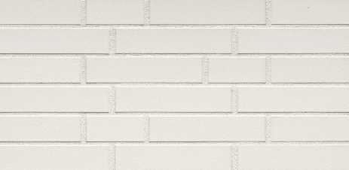

TEXTURE, TYPE & COLOR
Type: Ceramic brick slip for cladding, interior & exterior use.
Material: Fired clay
Texture: Flat, no sanding, no grain
Color: White
Corner slips available.

TECHNICAL CHARACTERISTICS
The slips are supplied under CE marking in accordance with EN 14411:2012 + EN 771-1:2015 with the following characteristics:
- Reaction to fire: Class A1
- Size L x W (height) x D according to DIN EN 771-1: ca. 240x52x10 mm
- Pieces/m²: ca. 54 (10 mm joint)
- Freeze-thaw resistance according to DIN EN 771-1: frost-resistant
- Water absorption according to DIN EN 772-21: ≤ 3 (M-%)
- Soluble salts: S2
- Kg/m² approx. (10 mm joint): 18 kg

INSTALLATION ADVICE
The brick slips should be mixed from different packs before installation. Freshly applied adhesive should always be protected.
Slips must be dry and dust-free before installation. Adhesive must be applied fully to both the substrate and the back of the slip using the buttering-floating method to ensure 100% coverage.

TRANSPORT AND STORAGE
Do not stack pallets on top of each other to avoid breakage. Store in a dry and dust-free environment on a solid surface.

The manufacturer reserves the right to change the product range and its characteristics. The user must always ensure they have the most recent product description. The data provided are based on information made available by the manufacturer.
This performance declaration is drawn up in accordance with Regulation No. 305/2011 (EU) under the sole responsibility of the manufacturer.

